Optimization algorithms

Quiz, 10 questions

**10/10 points (100%)**

**Congratulations! You passed!**

Next Item

Correct

1 / 1 points

1.

Which notation would you use to denote the 3rd layer’s activations when the input is the 7th example from the 8th minibatch?



*a*[3]{7}(8)



*a*[3]{8}(7)

**Correct**



*a*[8]{3}(7)



*a*[8]{7}(3)

Correct

1 / 1 points

2.

Which of these statements about mini-batch gradient descent do you agree with?



Training one epoch (one pass through the training set) using mini-batch gradient descent is faster than training one epoch using batch gradient descent.



One iteration of mini-batch gradient descent (computing on a single mini-batch) is faster than one iteration of batch gradient descent.

**Correct**



**You should implement mini-batch gradient descent without an explicit for-loop over different mini-batches, so that the algorithm processes all mini-batches at the same time (vectorization).**

Correct

1 / 1 points

3.

Why is the best mini-batch size usually not 1 and not m, but instead something in-between?



If the mini-batch size is m, you end up with stochastic gradient descent, which is usually slower than mini-batch gradient descent.

**Un-selected is correct**



If the mini-batch size is 1, you end up having to process the entire training set before making any progress.

**Un-selected is correct**



If the mini-batch size is m, you end up with batch gradient descent, which has to process the whole training set before making progress.

**Correct**



If the mini-batch size is 1, you lose the benefits of vectorization across examples in the mini-batch.

**Correct**

Correct

1 / 1 points

4.

Suppose your learning algorithm’s cost *J*, plotted as a function of the number of iterations, looks like this:

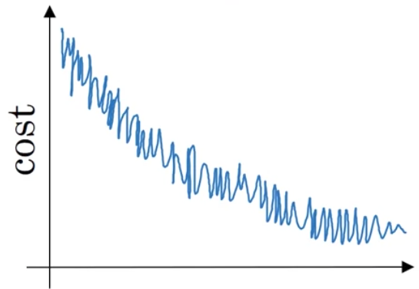

Which of the following do you agree with?



Whether you’re using batch gradient descent or mini-batch gradient descent, something is wrong.



If you’re using mini-batch gradient descent, this looks acceptable. But if you’re using batch gradient descent, something is wrong.

**Correct**



If you’re using mini-batch gradient descent, something is wrong. But if you’re using batch gradient descent, this looks acceptable.



Whether you’re using batch gradient descent or mini-batch gradient descent, this looks acceptable.

Correct

1 / 1 points

5.

Suppose the temperature in Casablanca over the first three days of January are the same:

Jan 1st: *θ*1=10*oC*

Jan 2nd: *θ*210*oC*

(We used Fahrenheit in lecture, so will use Celsius here in honor of the metric world.)

Say you use an exponentially weighted average with *β*=0.5 to track the temperature: *v*0=0, *vt*=*βvt*−1+(1−*β*)*θt*. If *v*2 is the value computed after day 2 without bias correction, and *vcorrected*2 is the value you compute with bias correction. What are these values? (You might be able to do this without a calculator, but you don't actually need one. Remember what is bias correction doing.)



*v*2=7.5, *vcorrected*2=7.5



*v*2=10, *vcorrected*2=7.5



*v*2=7.5, *vcorrected*2=10

**Correct**



*v*2=10, *vcorrected*2=10

Correct

1 / 1 points

6.

Which of these is NOT a good learning rate decay scheme? Here, t is the epoch number.



*α*=*etα*0

**Correct**



*α*=1*t*√*α*0



*α*=11+2∗*tα*0



*α*=0.95*tα*0

Correct

1 / 1 points

7.

You use an exponentially weighted average on the London temperature dataset. You use the following to track the temperature: *vt*=*βvt*−1+(1−*β*)*θt*. The red line below was computed using *β*=0.9. What would happen to your red curve as you vary *β*? (Check the two that apply)

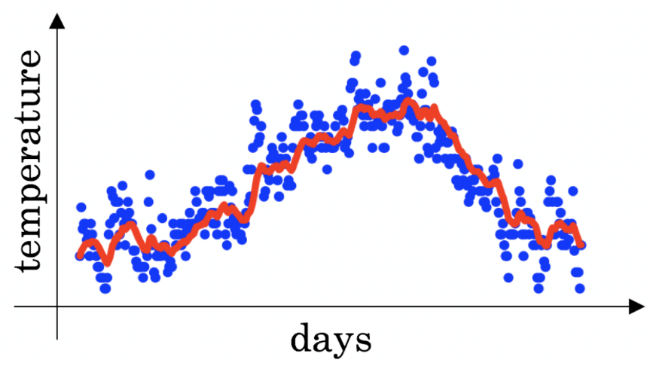



Decreasing *β* will shift the red line slightly to the right.

**Un-selected is correct**



Increasing *β* will shift the red line slightly to the right.

**Correct**

True, remember that the red line corresponds to *β*=0.9. In lecture we had a green line $$\beta = 0.98) that is slightly shifted to the right.



Decreasing *β* will create more oscillation within the red line.

**Correct**

True, remember that the red line corresponds to *β*=0.9. In lecture we had a yellow line $$\beta = 0.98 that had a lot of oscillations.



Increasing *β* will create more oscillations within the red line.

**Un-selected is correct**

Correct

1 / 1 points

8.

Consider this figure:

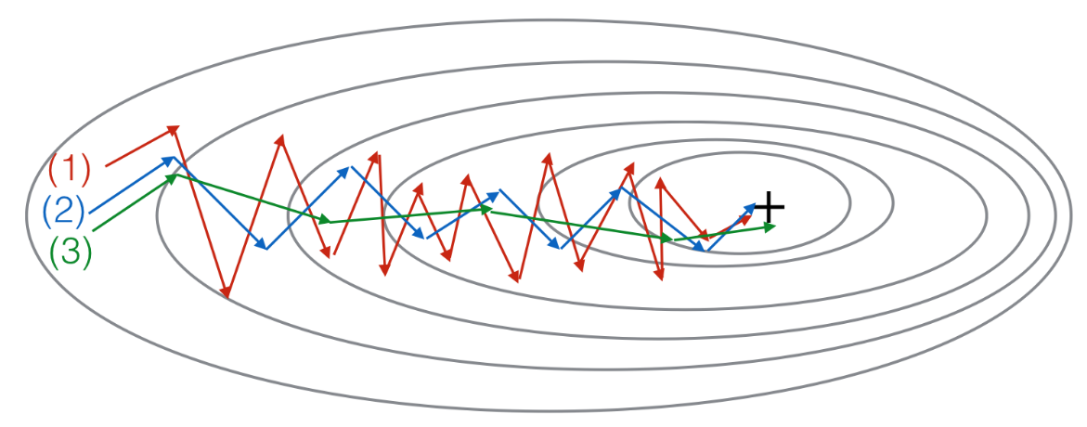

These plots were generated with gradient descent; with gradient descent with momentum (*β*= 0.5) and gradient descent with momentum (*β* = 0.9). Which curve corresponds to which algorithm?



(1) is gradient descent with momentum (small *β*). (2) is gradient descent. (3) is gradient descent with momentum (large *β*)



(1) is gradient descent with momentum (small *β*), (2) is gradient descent with momentum (small *β*), (3) is gradient descent



(1) is gradient descent. (2) is gradient descent with momentum (large *β*) . (3) is gradient descent with momentum (small *β*)



(1) is gradient descent. (2) is gradient descent with momentum (small *β*). (3) is gradient descent with momentum (large *β*)

**Correct**

Correct

1 / 1 points

9.

Suppose batch gradient descent in a deep network is taking excessively long to find a value of the parameters that achieves a small value for the cost function J(*W*[1],*b*[1],...,*W*[*L*],*b*[*L*]). Which of the following techniques could help find parameter values that attain a small value forJ? (Check all that apply)



Try mini-batch gradient descent

**Correct**



Try better random initialization for the weights

**Correct**



Try using Adam

**Correct**



Try tuning the learning rate *α*

**Correct**



Try initializing all the weights to zero

**Un-selected is correct**

Correct

1 / 1 points

10.

Which of the following statements about Adam is False?



Adam combines the advantages of RMSProp and momentum



Adam should be used with batch gradient computations, not with mini-batches.

**Correct**



We usually use “default” values for the hyperparameters *β*1,*β*2 and *ε* in Adam (*β*1=0.9, *β*2=0.999, *ε*=10−8)



The learning rate hyperparameter *α* in Adam usually needs to be tuned.